# NON-DISCLOSURE AGREEMENT (NDA)

For Internship

This Non-Disclosure Agreement ("Agreement") is made and entered into on this 01/07/2025, by and between:

GENXZAI Pvt. Ltd., a private limited company having its principal office at VIM 326 Sailashree Vihar, Bhubaneswar, India ("Disclosing Party"),

and

Nitin Goley, residing at 226 A, old city, Bareilly, Uttar Pradesh, India, enrolled as an intern with GENXZAI Pvt. Ltd. ("Receiving Party")

# Purpose

The Receiving Party understands that during the internship/employment at GENXZAI Pvt. Ltd., they may have access to confidential and proprietary information ("Confidential Information"). The purpose of this Agreement is to ensure the protection of such Confidential Information.

# Confidential Information

"Confidential Information" includes, but is not limited to:

* + - Source code, algorithms, and software
  + - Business plans and strategies
  + - Technical documents, designs, and system architecture
  + - Research data, AI/ML models, and unpublished reports
  + - Client and partner information
  + - Product concepts and prototypes

# Obligations of the Receiving Party

The Receiving Party agrees to:

* + - Keep the Confidential Information strictly confidential.
  + - Not disclose any Confidential Information to third parties without prior written consent.
  + - Use the Confidential Information solely for internship-related activities at GENXZAI.
  + - Return or destroy all confidential material upon termination of the internship.

# Exclusions

Confidential Information does not include information that:

* + - Is or becomes publicly available through no fault of the Receiving Party;
  + - Is disclosed under legal obligation with prior notice to GENXZAI.

# Term

This Agreement shall remain in effect during the internship/employment and for a period of three (3) years thereafter.

# Remedies

The Receiving Party acknowledges that unauthorized disclosure of Confidential Information may cause irreparable harm to GENXZAI and agrees that GENXZAI shall have the right to seek injunctive relief in addition to other legal remedies.

# No License

This Agreement does not grant the intern any rights in or to the Confidential Information except as expressly set forth herein.

# Governing Law

This Agreement shall be governed by and construed in accordance with the laws of India, and the courts of Odisha shall have exclusive jurisdiction.

IN WITNESS WHEREOF, the parties have executed this Non-Disclosure Agreement as of the date first above written.

GENXZAI Pvt. Ltd.

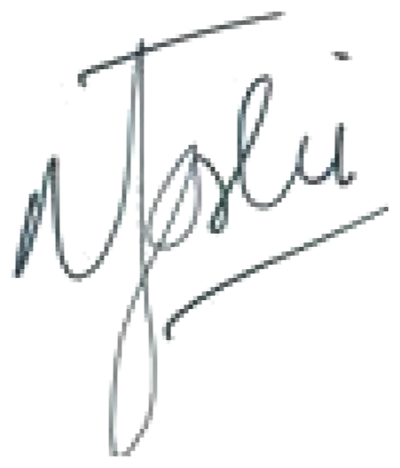

Narasingh Prasad Joshi Founder/CEO

Date: 24/06/2025

Intern

[Intern’s Full Name]

Date:

Nitin Goley

Date: 01/07/2025